FourSeasons.com
Frequently Asked Questions

This document contains an initial Frequently Asked Questions (FAQ) to address immediate customer issues.
FAQs are divided into:
- Website Launch
- Property Walk Through
- Reservation Process
- Registration and Accounts

If there are any new guest concerns or questions about the site that are not covered here, please email booking.engine.support@fourseasons.com.
Requests for additional FAQs should go to Robert.Simon@fourseasons.com.

Website Launch (Back to Top)
Questions related to the website launch include:
- How come I see the old site at work and the new site at home?
- Is there any way to force my machine to see the new site?
- Is the site only in English?
- What happened to the site search?
- What happened to my old account and reservation?
- Will reservations show up on the old site if I made it on the new one and vice versa?
How come I see the old site at work and the new site at home?
As we launch the site over the next few weeks a percentage of visitors world wide are being randomly routed between the old site and the new. So if you two laptops, each one may be send to a different site.
Is there any way to force my machine to see the new site?
Not really – just be patient. By December 26th, you will have a 60% chance of seeing the new site. Everybody will see the new site by January 4th, 2012.
Is the site only in English?
No, many properties still have links to their other languages in the old design. Some of these include the Chinese, German, and Japanese sites.
In 2012 we will be rolling out new languages in the new design every month, with Chinese and Japanese coming first in February.
What happened to the site search?
Site search is coming next in an early February release of the site. In the meantime, please see the Property Walk Through section and the related training videos to see how information is presented.
What happened to my old account and reservation?
Past reservations are being migrated into the new accounts as they are created.
If the guest has previously registered on the old fourseasons.com (created a booking profile), they will be able to log in to the new site with that account information. Users who have forgotten their password can request a new one - this process is now automated.
Will reservations show up on the old site if I made it on the new one and vice versa?
Reservations that were made on either site will show up on both sites, provided the user booked using their booking profile. The system that stores the reservations hasn’t changed, and both sites are connected to the same data.
For example, if someone was to make a reservation today for March, and visited the site a month from now, they would see their reservation when they log in. Login credentials (usernames and passwords) will persist to the new site.

Property Walk Through (Back to Top)
Questions related to the property pages:
- How can guests find the accommodations comparison chart?
- How can guests navigate the property photos?
- Where can guests find property menus?
- Where can guests find spa prices?
- How can guests find and select offers or packages?
- Where can guests find a map of the resort?
- Where can I see cancellation and guarantee policies?
- Where is information about local tours displayed?
How can guests find the accommodations comparison chart?
Guests can see a list of rooms at each property and a comparison chart of each room type. To locate this comparison chart, select “Accommodations” from the property pages. On the left side of the page, there is a link “Accommodations Fact Sheet.”
How can guests navigate the property photos?
From the property pages, select “Photos & Videos.” This opens a large-image viewer.
In order to advance to the next photo, click on the thumbnails at the bottom of the large image viewer, or click through on the small navigation arrows that are in a transparent box over the photos on the far right and far left.
In order to move out of the large image viewer, click the “X Close” link in the top right corner of the image.
Where can guests find property menus?
From the property pages, select “Dining.” Here, users can review dining options at the hotel or resort. Menus are displayed in the lower right corner where available. Click a menu to see the items. Prices are generally not viewable online.
Where can guests find spa prices?
From the property pages, select “Spa.” Selecting a treatment on the left side will display prices. At some properties, select services can be booked online.
How can guests find and select offers or packages?
From the property pages, select “Offers.” Offers are tied to dates, so it is important to select the dates before reviewing the offers.
Scroll through the offers using the right and left arrows on the sides of the offer box. The offers are also listed below, with the associated time frames.
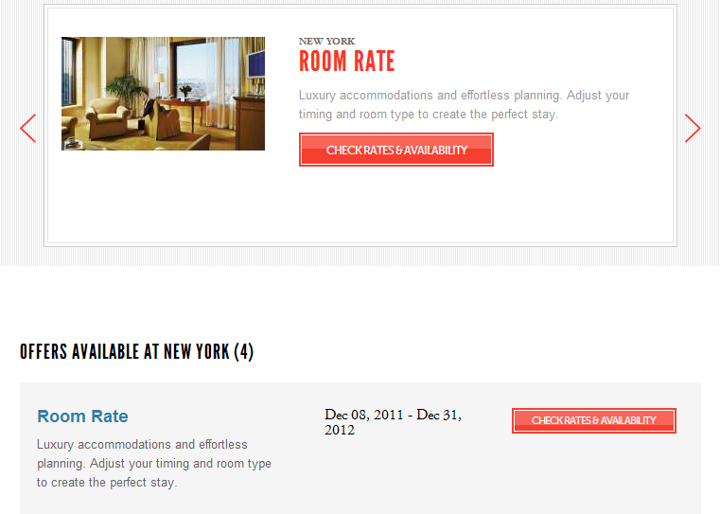
Where can guests find a map of the resort?
Resort map is available for many properties. From the property pages, select “Directions & Maps,” then select the “Resort Map” menu on the left side.
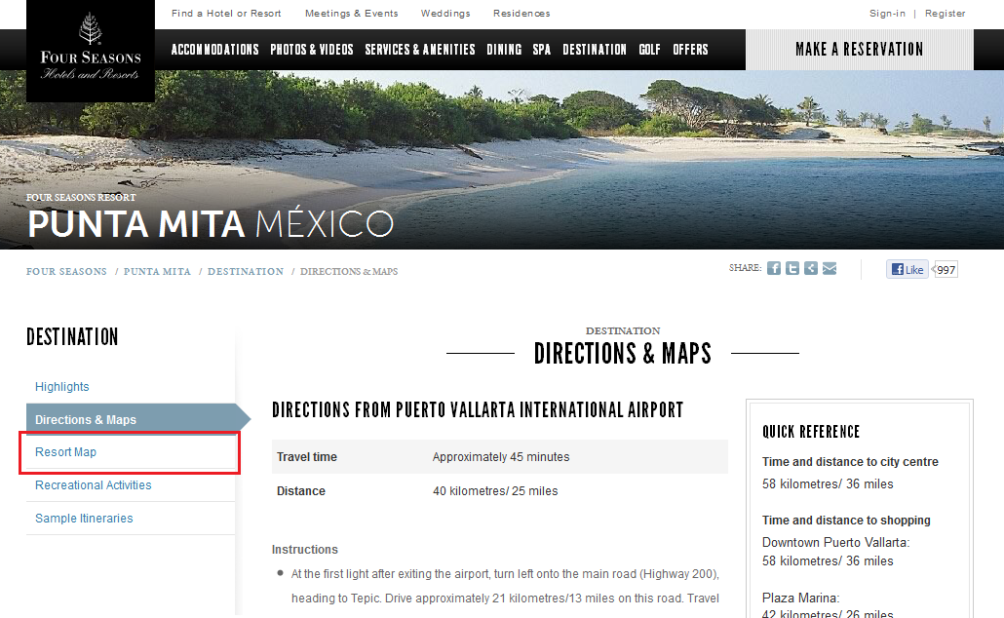
Where can I see cancellation and guarantee policies
General cancellation and guarantee policies:
From the property pages, click “Accommodations” to see a list of room types at the property. On the left side, select the room type with policies you are interested in. Policies are listed with blue background. Each policy can be expanded to see the full policy text.
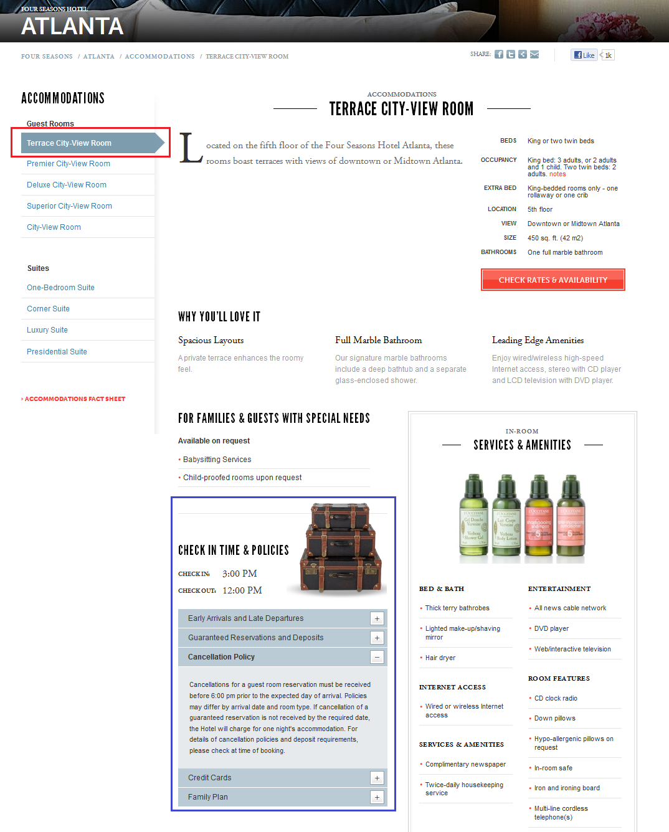

Reservation specific cancellation and guarantee policies:
Policies related to specific reservations are viewable in the booking flow only.
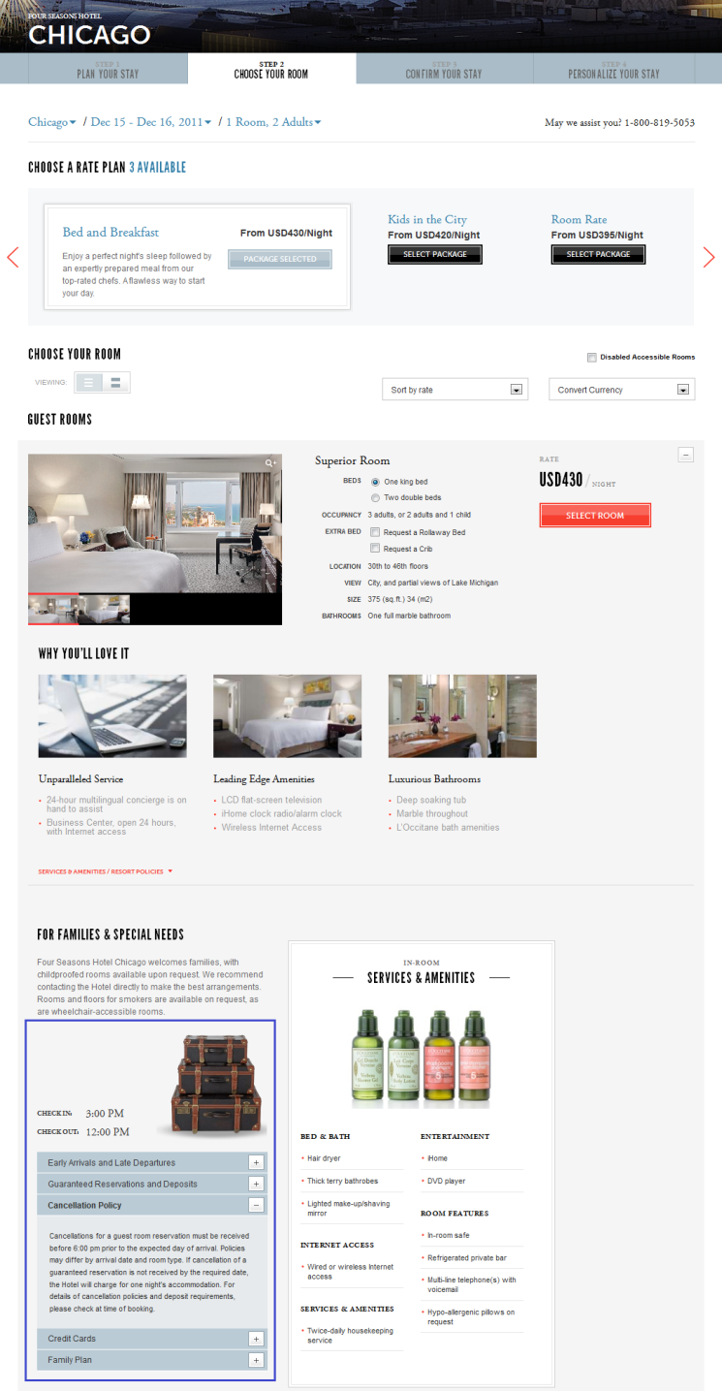
Where is information about local tours displayed?
From the property pages, select “Destination,” and then select “Recreational Activities” from the menu on the left. The tours are displayed – click “Learn More” to see more information about a tour.

Reservation Process (Back to Top)
Questions related to the reservation process include:
- What does the new booking process look like?
- What packages, rooms, and pricing do visitors see?
- What are the differences between the old booking process and the new one?
- How do I change the currency?
What does the new booking process look like?
Our new online reservation system has 4 steps.
- First a user enters the dates and place of their stay.
If a guest books from the fourseasons.com home page, they will need to also specify their destination. If they are booking from a property page, it’s not needed.
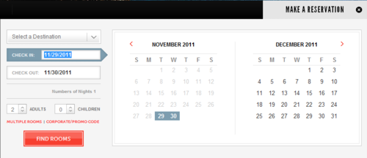
You can also pick the number of rooms, people, and if applicable, enter a corporate or promotional code.
- The next step is to pick a package and room-type.
We ask users to pick their packages first. The package selected affects the prices displayed beside each room.
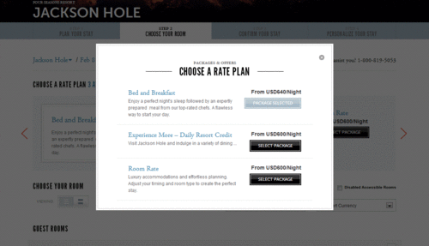
Next, we ask users to pick their room. The prices that are displayed beside each room relate to the package that has been selected. Users are able to change prices by using the currency conversion tool.
- Once a user has selected their room, we ask for their payment details.
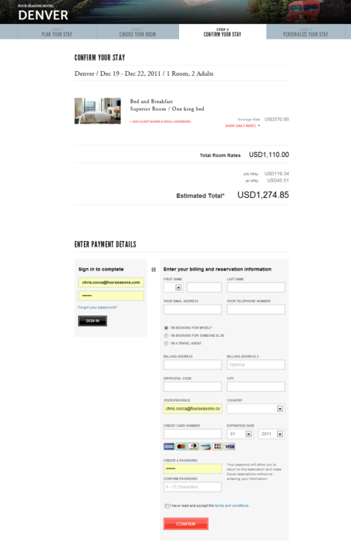
- Once paid, we confirm and ask how we help to personalize their stay. Here we ask them to tell us more about themselves and offer additional items like transfers and welcome amenities.
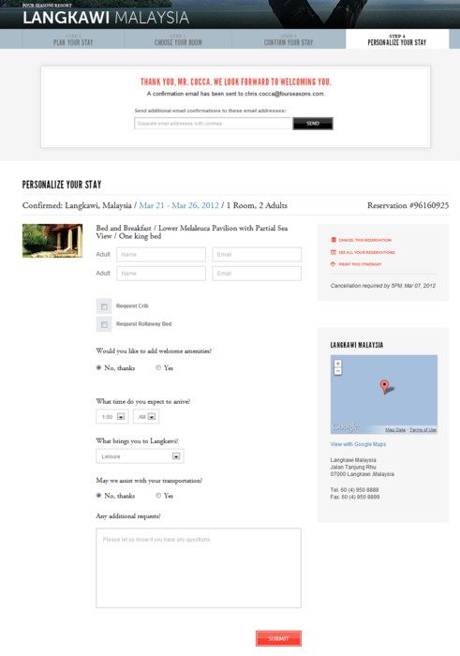

What packages, rooms, and pricing do users see?
Because we know a user’s dates, we only display the available packages and rooms for the time period they are interested in coming.
We ask users to pick their packages first. The package selected affects the prices displayed beside each room.
What are the differences between the old booking process and the new one?
In many ways, the booking flow works the same, even though it looks much different. A summary of the differences are:
- The check availability widget is available on almost every page, meaning that a user can start a booking from almost anywhere on the website.
- User accounts now combine the former interest profiles and booking profile into one central website account.
- The forgotten password process is automated - no human intervention required!
- Past and future reservations are accessible via the user’s profile. This is accessed by signing into the website.
- Multi-property packages are no longer bookable online - instead, we will direct interested guests to call.
How do I change the currency?
To change the currency from within the booking process, select the desired currency using the drop down menu.
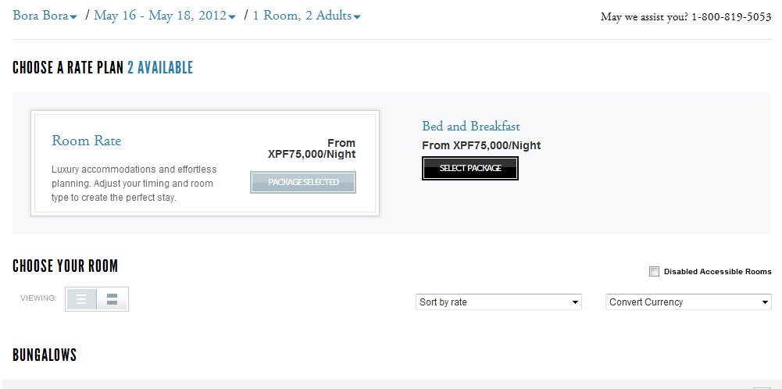
If the currency conversion is incorrect, an agent will be linked to a knowledge case.

Registration and Accounts (Back to Top)
Questions related to registration and accounts include:
- Do users need to create an account in order to book a room?
- Can you create an account without making a booking?
- Where can a past guest find their itinerary / receipt?
- If a user has created an account on the old fourseasons.com, will it work on the new one?
- Can I see a reservation online?
- Why do I need to sign in to see my reservation?
- Can I see a reservation later if I don’t create a user account?
- How can I reset my password?
- Do I need to sign in each time I use the website, or is there a way to remember me?
- How can I edit my user account, including saved credit card information?
Do users need to create an account in order to book a room?
No, users can book a room without creating an account. If they do create an account, they can access reservation details and save time in the future by not having to enter their personal information.
Can you create an account without making a booking?
Yes, this is done by clicking the “Register” link in the top-right corner of any page on the website.
Where can a past guest find their itinerary/receipt?
If the guest has registered for an account on the new fourseasons.com, they can access past reservations by logging in to the website by clicking the “sign-in” link in the top-right corner of any page on fourseasons.com.
Once logged in, they will be able to see a “Your Reservations” tab within their profile. All past and future reservations are stored here.
If a user has created an account on the old fourseasons.com, will it work on the new one?
If the guest has previously registered on the old fourseasons.com (created a booking profile), they will be able to log in to the new site with that account information.
Users who have forgotten their password can request a new one - this process is now automated.
Can I see a reservation online?
Yes, but only those reservations can be seen online which were created while the user was signed in and guest is logged in with the same user account.
Why do I need to sign in to see my reservations?
To identify guests and prevent unauthenticated access, we require guests to sign in to see reservation information.
Can I see my reservation later if I don’t create a user account?
No. The confirmation email contains direct link to cancellation only. If you were not signed in during booking you cannot access your reservation online.
How can I reset my password?
From any page in the site, click “Sign-in” at the very top of the screen. In the opening panel, click “Forgot Your Password.”
Next, enter the email address associated with your account and select “Submit.”
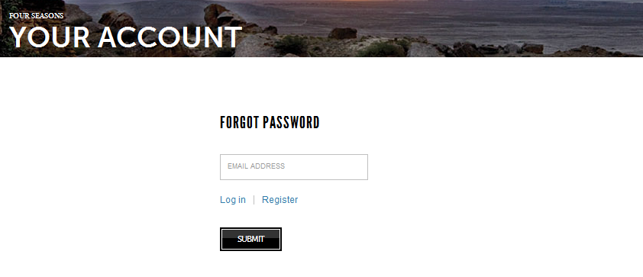
An email is sent to the email address provided with instructions regarding the password reset procedure.
A link in that email will take the user to a screen to change the password. On this screen the guest can simply enter a new password. After clicking the “Submit” button, the password becomes effective immediately, and the guest can sign in with the new password.
Do I need to sign in every time I use your website, or is there a way to remember me?
You only need to sign in if you want to retrieve current or past reservations, or want to create a new reservation you want to be saved.
Currently there is no way to remember you on a computer, after your session expires or you close the browser, you have to sign in again.
How can I edit my user account including saved credit card information?
After sign in, the Your Profile screen is automatically displayed. It can also be accessed by clicking the “My Profile” link at the top of the page.
Make any modification to the user account, including adding / removing credit cards, addresses, interests and regions than click the “Save” button.

